**ACROPOLIS INSTITUTE OF TECHNOLOGY AND RESEARCH**



**Seminar Document**

**Topic*:*** Lossless and Lossy Compression, Audio Image and Video compression

Submitted to: Submitted by :

Mr. Anil patidar Shivam Nirwani(210)

Sakshi Jain(CS130)

**Data Compression**

Data compression implies sending or storing a smaller number of bits. Although many methods are used for this purpose, in general these methods can be divided into two broad categories:

* Lossless methods
* Lossy methods

**LOSSLESS COMPRESSION:-**

In lossless data compression, the data after compression and decompression are exactly the same because of the method used in this kind of compression, which is compression and decompression algorithms are exact inverses of each other therefore no part of the data is lost in the process.

Redundant data is removed in compression and added during decompression.

Lossless compression methods are normally used when we cannot afford to lose any data.

**Application:-**

* In ZIP file formate lossless compression is used.
* In GNU tool gzip lossless compression is used.

In Computer Graphics-

* [PNG](https://en.wikipedia.org/wiki/Portable_Network_Graphics) – Portable Network Graphics
* GIF Graphic Interchangeable File
* [TIFF](https://en.wikipedia.org/wiki/Tagged_Image_File_Format) – Tagged Image File Format
* [FLIF](https://en.wikipedia.org/wiki/FLIF) – Free Lossless Image Format
* [JPEG-LS](https://en.wikipedia.org/wiki/Lossless_JPEG#JPEG-LS)
* [OpenCTM](https://en.wikipedia.org/wiki/OpenCTM) –3D triangle meshes

In Audio Codecs-

* [Adaptive Transform Acoustic Coding](https://en.wikipedia.org/wiki/Adaptive_Transform_Acoustic_Coding) (ATRAC)
* [Audio Lossless Coding](https://en.wikipedia.org/wiki/Audio_Lossless_Coding) (a.k.a MPEG-4 ALS)
* [Direct Stream Transfer](https://en.wikipedia.org/wiki/Super_Audio_CD#DST)
* [RealPlayer](https://en.wikipedia.org/wiki/RealPlayer)
* [WMA Lossless](https://en.wikipedia.org/wiki/Windows_Media_Audio_9_Lossless)

**Encoding Methods that uses LL Compression:-**

**Huffman coding:-**

Huffman coding assigns shorter codes to symbols that occur more frequently and longer codes to those that occur less frequently. For example, imagine we have a text file that uses only five characters (A, B, C, D, E). Before we can assign bit patterns to each character, we assign each character a weight based on its frequency of use.



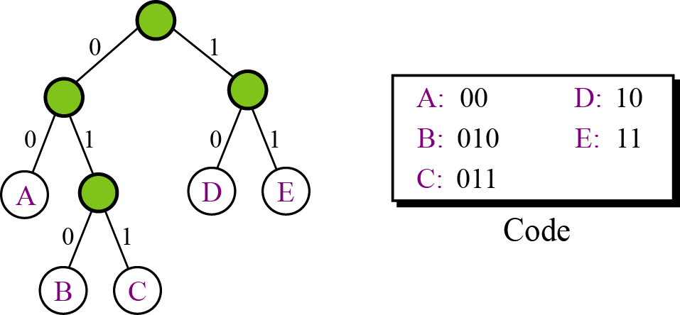

Encoding

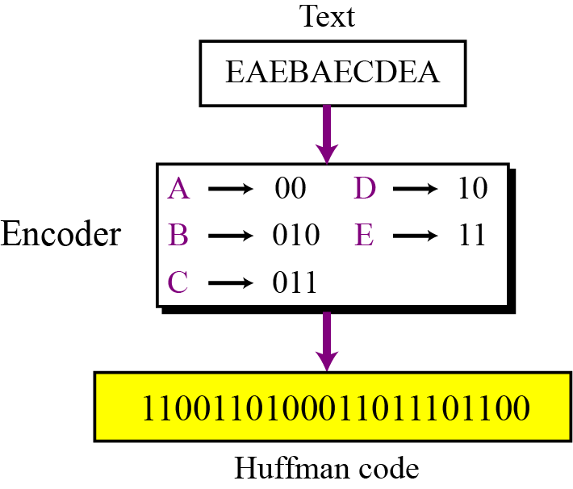

Decoding

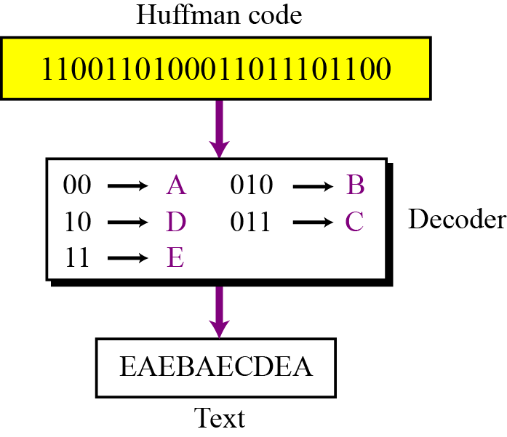

**Lempel Ziv encoding:-**

Lempel Ziv (LZ) encoding is an example of a category of algorithms called dictionary-based encoding. The idea is to create a dictionary or table of strings used during the communication session. If both the sender and the receiver have a copy of the dictionary, then previously-encountered strings can be substituted by their index in the dictionary to reduce the amount of information transmitted.

**Advantages of Lossless Compression:-**

* This method maintains the data quality.
* The integrity of data after compression remains same as the original data.
* The original data can be easily retrieved from the compressed.
* The algorithm for data compression and decompression is exact inverse of each other.

**Disadvantages:**

* It does not reduce the size of the data as much as other compression method.
* The statistical model used in the compression could occupy expensive size.
* This method can be less efficient over heterogenous data.

**LOSSY COMPRESSION METHODS:-**

Lossy compression technique permanently removes data from the original file by removing redundant and unrequired data. To reduce the disk space .

With lossy data compression we could even reduce an image's file size by more than 80%, with little noticeable effect.

Both JPEG and MP3 compression removes data from the original file, which may be noticeable upon close examination.

We could adjust the quality setting for desired quality and file size.

A file that uses greater compression will take up less space, but may not look or sound as good as a less compressed file.

* Image compression

JPEG (Joint Photographic Experts Group) encoding is used to compress pictures and graphics

* Video compression

MPEG (Moving Picture Experts Group) encoding is used to compress video

* Audio compression

MP3 (MPEG audio layer 3) for audio compression.

**Applications:-**

## Lossy data compression is primarily used for digital multimedia

* Lossy compression is very useful when there is a need for data but with restriction on the size.
* For faster transfer of bits over internet.
* In streaming data, we could adjust quality for less data consumption.

**Advantages:-**

* A compressed MP3 file may be one tenth the size of the original audio file and may sound almost identical.
* A JPEG image can be reduced by up to 80 percent of its original size without substantially affecting image quality.
* Using JPEG compression, we can decide how much loss to introduce and make a trade-off between file size and image quality.
* Transfer rate of data is higher.

**Disadvantages:-**

* The decompressed file can be quite different from the original file.
* The quality of file can be reduced at a drastic level.
* As in this method the bits are reduced there is always a chance for information loss.

**Image Compression – JPEG encoding**

An image can be represented by a two-dimensional array (table) of picture elements (pixels).

A grayscale picture of 307,200 pixels is represented by 2,457,600 bits, and a color picture is represented by 7,372,800 bits.

In JPEG, a grayscale picture is divided into blocks of 8 × 8 pixel blocks to decrease the number of calculations because, the number of mathematical operations for each picture is the square of the number of units.

The whole idea of JPEG is to change the picture into a linear (vector) set of numbers that reveals the redundancies. The redundancies (lack of changes) can then be removed using one of the lossless compression methods .

**Discrete cosine transform (DCT):-**

In DCT, Each block of 64 pixels goes through a transformation called the **discrete cosine transform (DCT)**. The transformation changes the 64 values so that the relative relationships between pixels are kept but the redundancies are revealed. The formula is given in Appendix G. P(*x*, *y*) defines one value in the block, while T(*m*, *n*) defines the value in the transformed block.

**Quantization:-**

 It is a [lossy compression](https://en.wikipedia.org/wiki/Lossy_compression) technique which is achieved by compressing a range of values to a single quantum value.

When the number of discrete symbols in a given stream is reduced, the stream becomes more compressible.

Mathematically-

After the T table is created, the values are quantized to reduce the number of bits needed for encoding. Quantization divides the number of bits by a constant number The divisor depends on the position of the value in the T table. This is done to optimize the number of bits and the number of 0s for each particular application.of bits even more. In most implementations, a quantizing table (8 by 8) defines how to quantize each value. and then drops the fraction. This reduces the required.

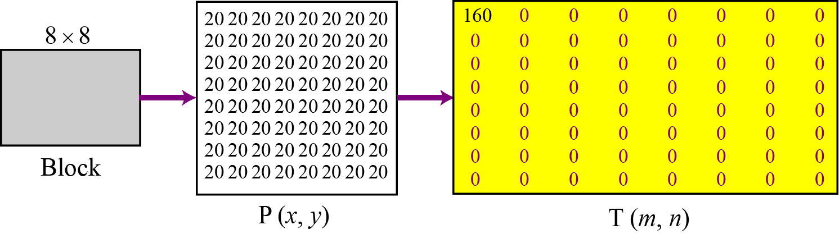

**Compression-**

After quantization the values are read from the table, and redundant 0s are removed. However, to cluster the 0s together, the process reads the table diagonally in a zigzag fashion rather than row by row or column by column. The reason is that if the picture does not have fine changes, the bottom right corner of the T table is all 0s.

JPEG usually uses run-length encoding at the compression phase to compress the bit pattern resulting from the zigzag linearization.

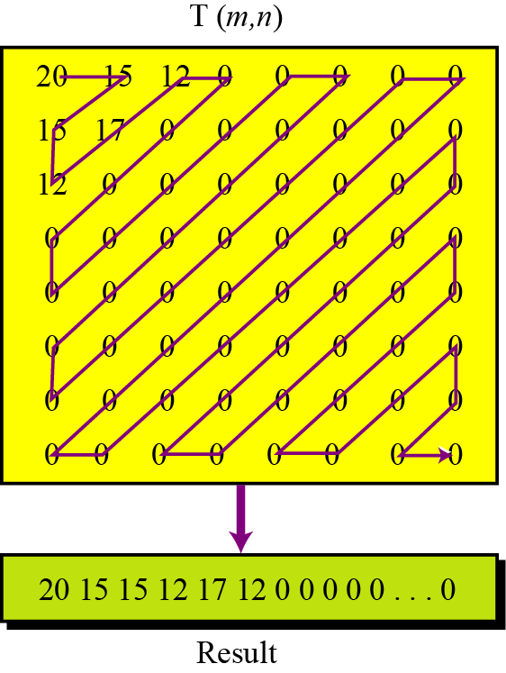

Reading the table

**Applications:-**

* It is used in image editing.
* On the internet for allowing web-designers to create image-rich sites without using much bandwidth or storage space.
* Some electronic devices, such as computers or cameras, may load large or uncompressed images slowly we can use image compression to make it compatible for these electronic devices.

**Advantages:-**

* We can compress the image till the desired size.
* The image takes up less space on the hard drive and retains the same physical size.
* Image compression allows for the faster loading of data on slower devices.

**Disadvantages:-**

* When an image reduces in size the compression program will discard some of the photo's data permanently.
* We could lose the high quality data and could be left with low quality.
* In a GIF or PNG file, the data remains even though the quality of the image could get receded.
* We are required to have backup if we want to restore the original quality if the compressed file has reduced it.

**Video compression – MPEG encoding**

Video compression is the process of encoding a video file in such a way that it consumes less space than the original file and is easier to transmit over the network/Internet.

It is a type of compression technique that reduces the size of video file formats by eliminating redundant and non-functional data from the original video file.

Video compression is performed through a video codec that works on one or more compression algorithms. Usually video compression is done by removing repetitive images, sounds and/or scenes from a video. For example, a video may have the same background, image or sound played several times or the data displayed/attached with video file is not that important. Video compression will remove all such data to reduce the video file size.

Once a video is compressed, its original format is changed into a different format which depends on the codec. The video player must support that video format.

The Moving Picture Experts Group (MPEG) method is used to compress video. In principle, a motion picture is a rapid sequence of a set of frames in which each frame is a picture. In other words, a frame is a spatial combination of pixels, and a video is a temporal combination of frames that are sent one after another.

In other words Compressing video means spatially compressing each frame and temporally compressing a set of frames.

**Spatial compression:-**

The spatial compression of each frame is done with JPEG, or a modification of it. Each frame is a picture that can be independently compressed.

**Temporal Compression:-**

In temporal compression, redundant frames are removed. When we watch television we receive 30 frames per second. However, most of the consecutive frames are almost the same. For example, in a static scene in which someone is talking, most frames are the same except for the segment around the speaker’s lips, which changes from one frame to the next.

**Application:-**

* It is used highly in the entertainment industry.
* HD televisions implemets video codecs to support and enhance video quality.

**Advantages:-**

* Redundant frames are removed results in reduced size of the video.
* Increases file transfer speed.

**Disadvantages:-**

* Affects the quality of video.
* Requires codec for compression.
* The respective media player must support the format of video file after compression.

**Audio Compression**

In [audio compression](https://en.wikipedia.org/wiki/Audio_signal_processing) we reduces the volume of loud [sounds](https://en.wikipedia.org/wiki/Sound) or amplifies quiet sounds.

We achieve this by reducing or compressing an [audio signal](https://en.wikipedia.org/wiki/Audio_signal)'s [dynamic range](https://en.wikipedia.org/wiki/Dynamic_range).

Audio compression can be used for speech or music. For speech we need to compress a 64 kHz digitized signal, while for music we need to compress a 1.411 MHz signal.

Two categories of techniques are used for audio compression: predictive encoding and perceptual encoding.

**Predictive encoding:-**

Predictive coding analyzes the speech signal by estimating the formants, removing their effects from the speech signal, and estimating the intensity and frequency of the remaining buzz.

The process of removing the formants is called inverse filtering, and the remaining signal after the subtraction of the filtered modeled signal is called the residue.

 It is one of the most powerful speech analysis techniques, and one of the most useful methods for encoding good quality speech at a low bit rate and provides extremely accurate estimates of speech parameters.

**Perceptual encoding: MP3**

The most common compression technique used to create CD-quality audio is based on the perceptual encoding technique. This type of audio needs at least 1.411 Mbps, which cannot be sent over the Internet without compression. MP3 (MPEG audio layer 3) uses this technique.

**Applications:-**

* Audio Compression is commonly used in [sound recording and reproduction](https://en.wikipedia.org/wiki/Sound_recording_and_reproduction).
* In [broadcasting](https://en.wikipedia.org/wiki/Broadcasting), for example in television broadcast.
* In [live sound reinforcement](https://en.wikipedia.org/wiki/Sound_reinforcement_system) where louder sound is required or variations in sound essential.
* Audio compressors are also used in some [instrument amplifiers](https://en.wikipedia.org/wiki/Instrument_amplifier) and vocal assists.

**Advantages:-**

* It reduces the file size thus, requires less disk space.
* For transfer of files less bandwidth is required.

**Disadvantages:-**

* The difference between compressed and uncompressed file can be huge, depending on the degree of compression.
* Could result in lower sound quality.